**Project Documentation**

**Insightstream: Navigate the News Landscape**

# Introduction

* **Project Title:** Insightstream: Navigate the News Landscape
* **Team ID:** NM2025TMID39963
* **Team Leader:** DURGA DEVI.M [sac2427csc5522@ssacollegechennai.com]
* **Team Members:**

_ILAKKIYA P [sac2427csc5465@ssacollegechennai.com]

_HARINI S [sac2227csc5368@gssacollegechennai.com]

_DILLI RANI E [sac2427csc5448@ssacollegechennai.com]

# Project Overview

**Purpose:**

Insight Stream is a data analytics and visualization platform that allows users to gather, process, and interpret insights from structured and unstructured data. It provides real-time dashboards, predictive analysis, and simplified decision-making support.

**Features:**

* Upload datasets in multiple formats (CSV, JSON, Excel)
* Real-time data visualization with interactive charts
* Dashboard creation and management
* Predictive analytics using AI/ML models
* User accounts with saved dashboards and reports
* Admin panel for data governance and access control

# Architecture

* Frontend: React.js with Material-UI for dynamic dashboards and visualizations
* Backend: Node.js + Express.js for APIs and server logic
* Database: MongoDB (stores users, datasets, dashboards, analytics reports) Analytics

Engine: Python-based microservices for ML and data processing

# Setup Instructions

**Prerequisites:**

* Node.js
* MongoDB
* Git
* Visual Studio Code
* Python 3.x with required libraries (pandas, scikit-learn, matplotlib)

**Installation Steps:**

# Clone the repository

git clone

# Install client dependencies cd client npm install

# Install server dependencies cd ../server npm install

# Install analytics dependencies cd

../analytics pip install -r requirements.txt

# Folder Structure

insight-stream/

├── client/ # React frontend

│ ├── components/

│ ├── pages/

│ └── assets/

├── server/ # Node.js backend

│ ├── routes/

│ ├── models/

│ ├── controllers/

│ └── middleware/

├── analytics/ # Python ML/AI services

│ ├── models/

│ ├── scripts/

│ └── notebooks/

└── README.md

# Running the Application

**Frontend:**

cd client npm start

**Backend:**

cd server npm start

**Analytics Engine:**

cd analytics python run.py

**Access:** Visit http://localhost:5173

# API Documentation

**User:**

POST /api/user/register – Create account

POST /api/user/login – Log in

**Datasets:**

POST /api/datasets/upload – Upload dataset

GET /api/datasets/:id – Get dataset details

**Dashboards:**

POST /api/dashboards/create – Create dashboard

GET /api/dashboards/:userId – Retrieve dashboards

# Authentication

* JSON Web Token (JWT) for login sessions

* Role-based access control for users and admins

# User Interface

* Landing Page with featured analytics use-cases

* Dataset Upload Page

* Interactive Dashboard with charts and graphs

* Admin Panel for user and dataset management

# Testing

* Manual testing for dataset upload, chart rendering, and dashboard creation

* Tools: Postman, Chrome DevTools, Jest for frontend tests, PyTest for analytics engine

# Screenshots or Demo

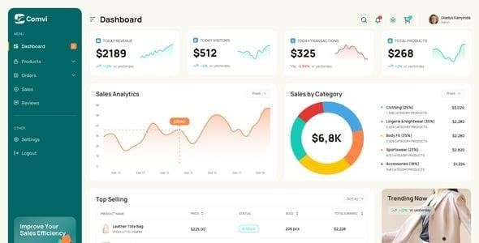

# Known Issues

* Large dataset uploads may take extra time

* Real-time predictive analysis limited to small datasets

* Occasional rendering delay for complex charts

* Mobile UI optimization in progress

# Future Enhancements

* Integration with cloud data sources (AWS S3, Google BigQuery)

* AI-driven automated insights